# Methodology

Started with over 400 cos – selected with the rough ‘turnover’ that Sales Nav provides, under the turnover of the “Top 100” from MRS. Also assessed by employee count.

LI industries used: “Market Research”, “Information Services”, “Business Consulting and Services”, and “Research Services”. Limitations: LI Sales Nav does not instinctively omit other industries, meaning some inappropriate companies were added to the cohort.

Used excel to identify keywords in the LinkedIn page Descriptions and Summaries of each company.

Used Clay for the following:

Keyword website searches

Company funding information

Scrape of Endole/Companies House for Revenue detail following a website scrape for company registration IDs

Scrape of website for industries, no of offices, no of countries with offices, products and services offered, parent company information, and client details.

Data collected, collated, assessed, reduced and analysed using Excel and Power Query for assistance.

# Research and Analysis

## Industry & Focus

*Figure 1 LI Employee Range X Sum of Industry Count*

*SME’s have a high industry count – offering their services to multiple sectors. Bigger company LinkedIn Employee Ranges offer services to niche industries, e.g. Pharmaceutical.*

*Figure 2 Top 10 Industries by Count.*

*Figure 3 Industry by Count.*

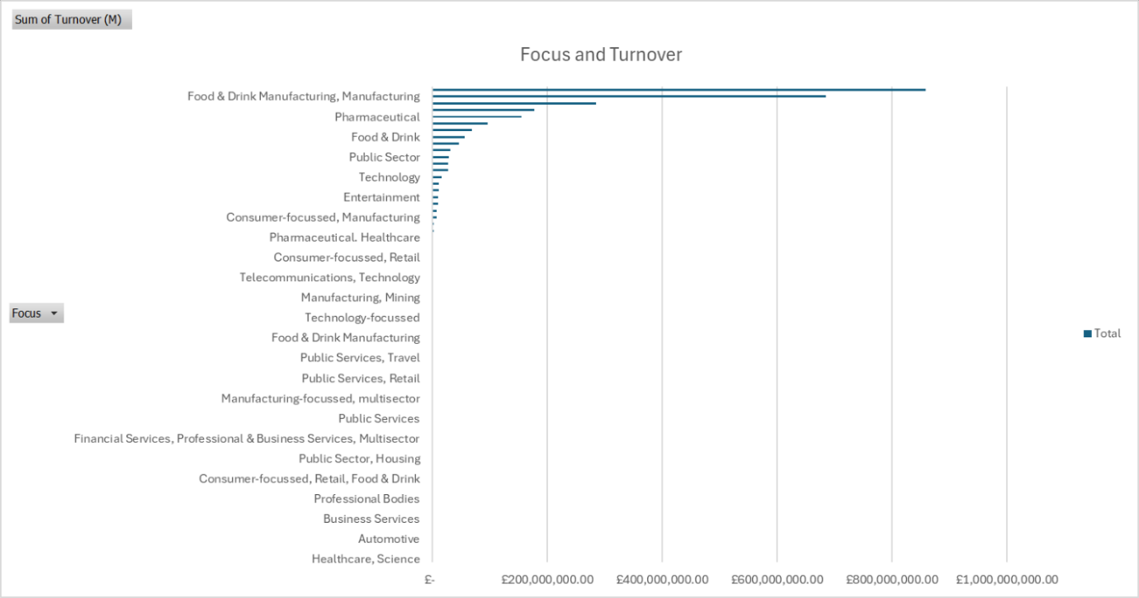*Figure 4 Company Industry Focus Count X Turnover.*

*Multisector-focussed companies dominate the turnover sum available in the sample. Despite Pharmaceutical being a niche, specialised industry, turnover remains high.*

*Figure 5 Company Industry Focus X No. Countries with Offices.*

*Multisector-focussed companies have a noticeably higher sum of the number of global offices (41%, overall 49% when including “consumer-focussed, multisector” ). As expected, those companies that focus on the public sector have a local, UK-based presence, e.g. local authority and govt work. The mean no of countries with offices (by Focus) is 12.*

*Figure 6 Top 10 Industries by Revenue.*

| **Top 10 Focus X Worldwide Offices** |  |
| --- | --- |
| **Focus** | **Sum of No Countries with Offices** |
| Multisector | 361 |
| Consumer-focussed, Multisector | 74 |
| Pharmaceutical, Healthcare | 58 |
| Technology | 53 |
| B2B professional industries | 33 |
| Manufacturing | 28 |
| Energy & Utilities | 24 |
| Financial Services | 22 |
| Financial Services, B2B | 18 |
| b2B professional industries, IT | 18 |
| **Grand Total** | **689** |

| **Top 10 Focus X Industry Count** |  |
| --- | --- |
| **Focus** | **Sum of Industry Count** |
| Multisector | 720 |
| Consumer-focussed, Multisector | 91 |
| Public Sector | 44 |
| Pharmaceutical, Healthcare | 44 |
| Financial Services, Professional & Business Services, Multisector | 30 |
| Public Sector-focussed, Multisector | 29 |
| B2B professional industries | 28 |
| (blank) | 23 |
| Manufacturing | 22 |
| Technology | 16 |
| **Grand Total** | **1047** |

*Figure 7 Industry Count X Focus*

*Multisector holds the greatest sum of industry count. The high Public Sector count indicates that there are a great number of companies in the sample that offer services to the public sector, however as per previous note, these companies are UK-based.*

*Figure 8 Sum of Efficiency – Sum of Turnover X LI Emp Count per Focus (Top 10). This analysis may be limited by the data present. This indicates that “Food & Drink Manufacturing” has the greatest efficiency, however the data is skewed, as “Auction Houses” only account for a single company in the sample with a high revenue.*

*Figure 9 The Average of Efficiency (turnover/emps).*

*This data demonstrates that Mining is the topmost-efficient industry, followed by Defense, Aerospace, Sport and Agriculture/Farming. Please note that this data is skewed by limited turnover data in the dataset.*

*Figure 10 Average of Efficiency X LI Emp Range. There is little correlation between the Average of Efficiency and LI Emp Range, bar the presence of ’51 to 200’ sized companies (SME) generally holding a higher average (bar “Public Sector” as an outlier). Generally, the employee range “11 to 50” is present and greatest in all noted industries, bar” Manufacturing”, and it is absent from “Packaging” completely. “Sport”, and “Public Sector”” hold employee ranges between 11 to 500 employees.*

| **Top 10 Industries** | **Average of Efficiency** |
| --- | --- |
| Mining | £13,666,282.05 |
| Defense | £11,950,297.62 |
| Aerospace | £11,913,897.85 |
| Sport | £9,356,659.82 |
| Agriculture & Farming | £8,020,888.07 |
| Medical Devices | £6,049,578.72 |
| Packaging | £5,775,076.48 |
| Public Sector | £5,343,784.62 |
| Fashion | £5,093,970.87 |
| Manufacturing | £4,349,247.53 |
| **Grand Total** | **£6,986,799.79** |

*Figure 11 Some of topmost efficient industries appear to mostly belong to industrial-based sectors, whereas others pertain to consumer-focussed and entertainment industries, plus public sector and civil functions.*

## Revenue

*Figure 12 Average Turnover X Employee LI Range. As expected, the average turnover is ‘generally’ higher the greater the company size. However, the analysis is limited by the data available, and the “LI employee count” is not comparable to the “LI Employee Range”.*

*Figure 13 Sum of Turnover X LI Range. The LI Ranges “11 to 50” and “51 to 200” (SME ranges) have the highest sum of turnover.*

*Figure 14 Average Turnover X Industry. The industry, "Mining", has the greatest average turnover in the data set. This industry is followed by multiple other 'industrial'/'manufacturing' industries. This data is similar to the Average of Efficiency data above. The outlier of similar industries with the highest average turnover is “Sport” and “Defense”.*

*Figure 15 Sum of Turnover X Sum of LI Emp Count. There is no correlation between turnover and LI emp count.*

*Figure 16 Average Turnover X LI Employee Range. The majority of the Top 10 Industries by Average Turnover belong to the LI Emp Range “11 to 50” and “51 to 200” (both SME ranges). There is no correlation between LI Emp Range and Average Turnover in this dataset. Although the LI emp ranges “11 to 50” and “51 to 200” are widespread amongst the top 10 industries, they account for just 12% and 18% of the average revenue respectively. These two ranges however make up 33% and 28% of the SUM of revenue respectively.*

*Figure 17 Amending the 'LI employee count' data by range, the data shows that those SME companies of between 11 to 50 persons has a greater turnover value. The average turnover for all revenue data in the data set is £40,454,157.77*

## Funding

| **UK HO Location** | **Sum of Total Funding Raised** |
| --- | --- |
| London, England, United Kingdom | £1,298,441,092,866.00 |
| Glasgow, Scotland, United Kingdom | £16,389,410,000.00 |
| Maidstone, England, United Kingdom | £16,388,020,000.00 |
| Hertford, England, United Kingdom | £4,503,339,640.00 |
| Enfield, England, United Kingdom | £3,838,956,300.00 |
| Manchester, England, United Kingdom | £1,927,620,226.00 |
| Colchester, England, United Kingdom | £1,439,982,800.00 |
| Warwick, England, United Kingdom | £619,804,240.00 |
| Leeds, England, United Kingdom | £552,099,780.00 |
| Edinburgh, Scotland, United Kingdom | £500,000,000.00 |
| **Grand Total** | **£1,344,600,325,852.00** |

*Figure 18 Head Office Location X Total Funding Raised. London makes up 97% of the total funding raised.*

| **Industry** | **Sum of Total Funding Raised** |
| --- | --- |
| Consumer Goods/FMCG | £ 1,220,940,147,218.00 |
| Manufacturing | £ 1,203,351,131,742.00 |
| Energy & Utilities | £ 1,192,484,342,935.00 |
| Public Sector | £ 1,186,344,458,800.00 |
| Financial Services | £ 94,930,113,075.00 |
| Media | £ 85,210,900,785.00 |
| Healthcare | £ 57,594,782,356.00 |
| Technology | £ 49,892,831,006.00 |
| Food & Beverage Manufacturing | £ 44,302,454,703.00 |
| Retail | £ 35,009,518,009.00 |
| **Grand Total** | **£ 5,170,060,680,629.00** |

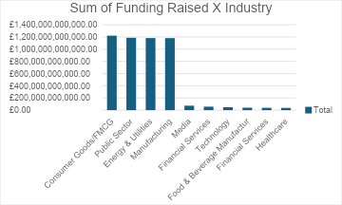

*Figure 19 Sum of Total Funding Raised X Industry (Top 10). Best funded industries in dataset.*

| **Top Clients by Funding Raised** | **Sum of Total Funding Raised** |
| --- | --- |
| OFQUAL | £1,186,324,958,800.00 |
| Bayer | £1,181,229,400,000.00 |
| SSE Energy | £1,181,229,400,000.00 |
| Project Liberty | £1,181,229,400,000.00 |
| Munich Security Conference | £1,181,229,400,000.00 |
| U.K. Cabinet Office | £1,181,229,400,000.00 |
| British American Tobacco | £1,181,229,400,000.00 |
| Centre for Social Justice | £1,181,229,400,000.00 |
| Onward | £1,181,229,400,000.00 |
| Microsoft | £32,245,207,763.00 |
| **Grand Total** | **£10,668,405,366,563.00** |

*Figure 20 Top Clients X Funding Raised. This confirms Fig 19 and demonstrates the broad array of industry/top clientele pertaining to funded companies in the dataset.*

## Companies

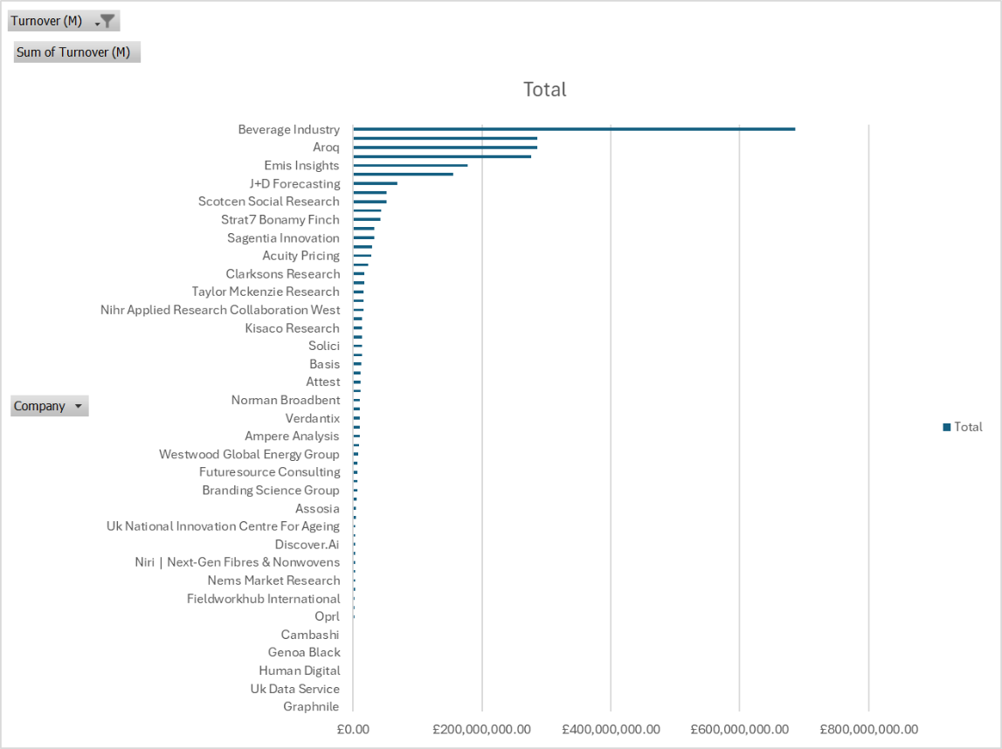

*Figure 21 Turnover X Company. The company “Beverage Industry”, has the greatest turnover value by a considerable lead. They are followed by, “GBI Research”, “Aroq”, “Genscape” and “Emis Insights”.*

| ***Top 10 Companies by Turnover*** |  |
| --- | --- |
| ***Companies*** | ***Sum of Turnover (M)*** |
| *Beverage Industry* | *£685,880,000.00* |
| *Aroq* | *£285,500,000.00* |
| *Gbi Research* | *£285,500,000.00* |
| *Genscape - Now Part Of Wood Mackenzie* | *£276,190,000.00* |
| *Emis Insights* | *£177,677,000.00* |
| *Sgs Vitrology* | *£155,390,000.00* |
| *J+D Forecasting* | *£68,460,000.00* |
| *Lumina Intelligence* | *£52,590,000.00* |
| *Scotcen Social Research* | *£51,720,000.00* |
| *Future Thinking Uk* | *£43,780,000.00* |
| ***Grand Total*** | ***£2,082,687,000.00*** |

*Figure 22 Top 10 Cos X Turnover. Mean value - £208,268,700 (M)*

*Figure 23 Turnover X Offices X Company. There is no correlation between the no. of offices and turnover in the top 10 companies by revenue. The mean turnover in the data set is £208M, whilst the mean no. offices is 7.3*

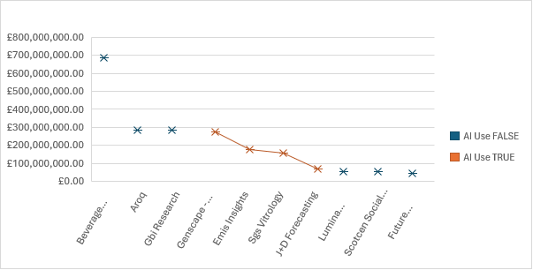

*Figure 24 Sum of Turnover X AI Use, Top 10 Cos by Revenue. The majority of top cos by revenue do not use AI (67%). Those that do use AI make up the middle values for turnover sum (median – £166.5M)*

*Figure 25 None of the Top 10 companies by revenue are SaaS/Platform-based MR cos.*

*Figure 26 Top 10 companies by revenue X parent companies. All the companies in the data set (top 10) have a parent company, bar one. Two Cos (“Aroq” and “GBI Research”) share a parent company.*

*Figure 27 Top 10 Cos by Revenue X Industry Focus. The data shows a broad mix of specialist and multisector industry focusses. 40% of the focus in this dataset is ‘multisector’, with 20% “Food & Drink” oriented and another 20% “B2B” related.*

*Figure 28 LI Emp Count X No Countries w/ Offices. Correlation – generally, the higher the employee count, the greater the no. of countries with offices.*

*Figure 29 Top 10 Cos by Revenue X total funding raised. 50% of cos in the data set received funding. Of these five, three companies have a specialised industry focus (“Pharmaceutical”, “Energy & Utilities”, Food & Drink Manufacturing”) and the remaining two are Multisector.*

*Figure 30 Top 10 Co by Revenue X AI use. 60% of the Top 10 cos by revenue do not use AI.*

*Figure 31 Top 10 Co by Revenue X Top Products and Services. The following graph demonstrates a vast mix of Products and Services offered by the top companies.*

| **Top 10 Co Services** |  |  |
| --- | --- | --- |
| **Aroq** |  |  |
| Consultancy | Newsletters |  |
| Custom Solutions | Report Store |  |
| Direct Data Services | Thematic Intelligence |  |
| Free Intelligence | Company Profiles |  |
| Intelligence Centers |  |  |
| Market Intelligence |  |  |
| Marketplace |  |  |
| **Beverage Industry** |  |  |
| Industry Reports | Research |  |
| News | Analysis |  |
| **Emis Insights** |  |  |
| Business Research | Market Intelligence & Strategic Planning |  |
| Credit & Risk | Sales & Marketing |  |
| M&A & Investment | Academic Research |  |
| **Future Thinking Uk** |  |  |
| Audience & panel | Customer experience | Market understanding |
| Brand development | Data collection & analytics | MarketVue |
| BrandVue | Employee experience | MillionaireVue |
| Communication effectiveness | Essentials | Product development |
| Savanta Business Essentials | Technology & platforms | Public policy |
| Savanta Essentials | All omnibus & trackers |  |
| **Gbi Research** |  |  |
| Frontier Pharma | Therapy Analysis | Other Analysis |
| MedTech | CBR Pharma Insights |  |
| **Genscape - Now Part Of Wood Mackenzie** |  |  |
| Consulting | Hydrogen | Oils & Chemicals |
| Emissions & Carbon Management | Lens Direct | Power and Renewables |
| Energy Transition Scenarios & Technologies | Lens Direct - API | Product training |
| Gas & LNG | Lens Platform | Subsurface |
| Help and support | Metals & Mining | Upstream |
| Supply Chain Analytics platform | Wood Mackenzie Lens |  |
| Trading Analytics | Commodity Trading Analytics |  |
| **J+D Forecasting** |  |  |
| Biomedtracker |  |  |
| Business Development & Licensing | Competitive Landscape Analysis | Evaluate Omnium |
| Commercial Opportunity Assessment | Consulting & Analytics | Evaluate Pharma |
| Company Profiling | Custom Analytics | Asset Screening |
| Competitive Intelligence | Pharma Forecasting Training | Market Opportunity Sizing |
| Custom Model Build | Portfolio Optimization | Datamonitor Healthcare |
| Evaluate Epi |  |  |
| **Lumina Intelligence** |  |  |
| Convenience Tracking Programme | Grocery Data Index | Wholesale data and insight solutions |
| Eating & Drinking Out Panel | Symbol Track | Bespoke Consultancy |
| **Scotcen Social Research** |  |  |
| Evaluation | Quantitative Research |  |
| NatCen Opinion Panel | Surveys |  |
| Qualitative Research | Analysis |  |
| **Sgs Vitrology** |  |  |
| cGMP Testing | Vaccine Services |  |
| Custom Assay Development | Virology Testing |  |
| GLP Testing | Biopharmaceutical Contract Research Services |  |
| Molecular Biology Testing |  |  |

## Offices

*Figure 32 Mean and Median values for the data set re offices and office locations.*

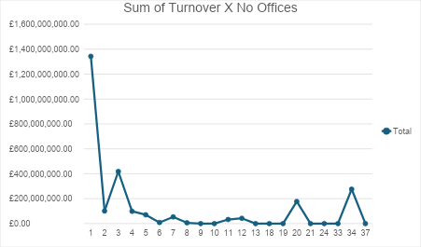

*Figure 33 Sum of Turnover X No Offices. There is no correlation between no. of offices and the sum of turnover in the data set.*

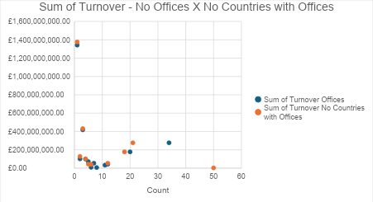

*Figure 34 Sum of Turnover – no. offices X no countries with offices. Both follow a similar trend in that the lower the no offices/country count, the higher the revenue.*

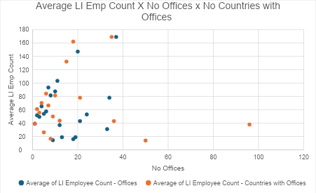

*Figure 35 Distribution of LI Emp Count X Offices. Generally, we see that most companies in the data set have less than 20 offices with an average emp count below 100.*

*Figure 36 The greatest count of UK Head offices belongs to the location of “London, England, United Kingdom”*

*Figure 37 The greatest turnover for UK Head Office locations also belongs to “London, England, United Kingdom”. “London Colney” may be an export error.*

## Parent Co & Offices

*Figure 38 No. Countries with Offices X Companies with a Parent Co*

*Individual companies offer global services. Even the smaller companies in the sample have a global presence.*

## Website Keyword Presence

*Figure 39 The majority of companies had the phrase, “Market Research” present on their website (84%)*

*The majority of companies had the word "qualitative" present in their website (67%)*

*The majority of companies had the word "Strategic" present in their website (86%)*

*Most companies did* ***not*** *have the keyword "AI" present on their website (54%)*

*Most companies did* ***not*** *have the keywords "artificial intelligence" present on their website (64%)*

## AI Use

*Figure 40 Count of AI Use. The majority of companies in the dataset do NOT use AI technology (80%).*

*Figure 41 Average Turnover X AI Use. Whilst AI Use remains low amongst the companies in the data set, the turnover value is greater in those that do use AI.*

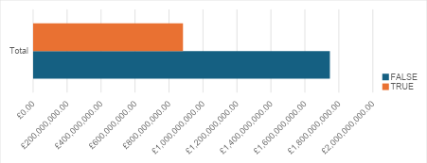

*Figure 43 The SME LI Emp Ranges (“11 to 50” and “51 to 200”) both have the greatest number of companies in the data set that do* ***not*** *use AI. In addition, most of the companies that* ***do*** *use AI belong to these cohorts also (84%).* A screenshot of a graph

*Figure 44 LI Emp Range altered by LI Count X AI Use. NB the majority of these companies (67%) are range 11 to 50 emps. 80% do not use AI, vs 20% who do in these ranges.*

*Figure 45 Sum of Turnover X AI Use. The greatest turnover belongs to those companies that do not currently use AI.*

*Figure 46 Funding X AI use. There is no correlation between funding and AI use.*

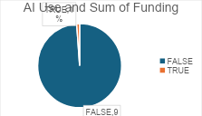

*Figure 47 AI Use X Sum of Funding. The vast majority of funded companies do NOT use AI.*

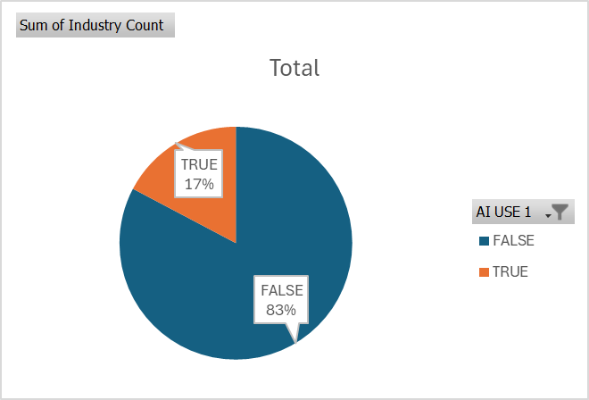

*Figure 48 AI use and Industry Count. Hypothesis – the greater the industry count/the greater the prevalence of multisector companies, the less-likely the use of AI?*

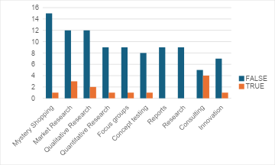

*Figure 49 Count of AI Use X Products and Services. The majority of top Products and Services do not use AI. The product/service “Consulting” however only 55% of cos offering “consulting” did not use AI. No AI was found to be used for “reports” and “Research”. "Research" and "Reports" do not have any corresponding companies that use AI. Companies that offer "consulting" as a service have similar numbers of AI vs no AI as part of their offerings in this sample*

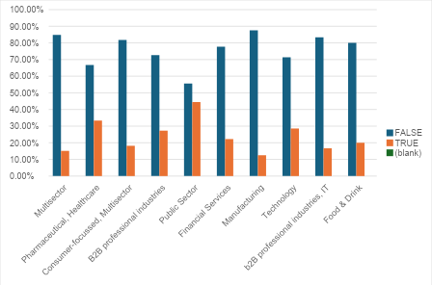

*Figure 50 AI Use X Company Industry Focus. Of the top focus sectors, multisector has the greatest variance (69%) between AI Use (True and False). Public Sector has the smallest variance between TRUE AND FALSE (11%). The mean percentage difference between TRUE and FALSE is 52%.*

*Figure 51 AI Use by Industry Count (top 10). There is a stark contrast between those that do not use AI and those that do, with an average % gap of 58% per industry.*

## Products & Services

*Figure 52 Top 10 Products and Services by Count. NB 'Surveys' most likely in Top 10 Products and Services by Count, however this is not seen due to the variations of 'survey' services in the sample.*

*Figure 53 Top 10 Products and Services by Count.*

*Figure 54 Top 10 Products and Services by Sum of Turnover. NB many of these are specific per company (trademarked products etc) so this may not be the most accurate representation of the data. Results for Top Products/Services by Turnover is skewed by limitations in number of turnover values available in sample*

*Figure 55 Top 10 Products and Services X Employee Range (LI Emp Count by Range Size). Employee Range “11 to 50” accounts for 95% of the revenue sum.*

*Figure 56 The Top Industries by Top Products and Services show a fairly even distribution.*

*Figure 57 Top Products and Services X Top Industries. There is a fairly even distribution of top industries for the top products and services noted.*

*Figure 58 Revenue Sum X LI Emp Count (LI Emp Range modified by LI Emp Count). This demonstrates that most companies with a high turnover belong to the “11 to 50” bracket. For companies that offer revenue data, the vast majority of the top 10 Products and Services belong to companies of the size 11-50. However, "Consulting" corresponds to 51-200 employees solely.*

## Notable Clients

*Figure 59 Top 10 clients by sum of count. The top clients noted belong to and overlap between several industries – Food & Beverage Manufacturing/Services, Technology, Consumer Goods/FMCG, Retail. These top clients are global, renowned vast entities.*

*Figure 60 Demonstration of Industry overlap for top clients.*

*.*

## Compliance

## 

*Figure 61 – Companies X Compliance. The majority of companies are not compliant with the security requirements requested. In total, 82% of the compliance count belongs to the “False” category. Less than 5% of companies were marked “TRUE” for all three compliance categories, with 61% having none of the compliance criteria fulfilled. 0 of companies in the data set that use AI were complaint on average, with only 7% of companies complaint with all three standards, and just 28% adhering to one. Likewise, those companies that do not use AI had an average compliance criteria fulfilment of 0.5/3. 4% of companies had all three criteria met, with just 24% having met a single compliance criteria.*

| **Industry** | **Sum of Compliance Count** |
| --- | --- |
| Technology | 43 |
| Financial Services | 39 |
| Retail | 38 |
| Consumer Goods/FMCG | 37 |
| Healthcare | 35 |
| Manufacturing | 31 |
| Energy & Utilities | 30 |
| Telecommunications | 28 |
| Transport | 27 |
| Construction | 26 |
| **Grand Total** | **334** |

*Figure 62 Top 10 industries by Compliance Count*

| **Focus** | **Count of Compliance** |
| --- | --- |
| (blank) | 1048289 |
| Multisector | 119 |
| Pharmaceutical, Healthcare | 18 |
| Consumer-focussed, Multisector | 11 |
| B2B professional industries | 11 |
| Public Sector | 9 |
| Financial Services | 9 |
| Manufacturing | 8 |
| Technology | 7 |
| b2B professional industries, IT | 6 |
| **Grand Total** | **1048487** |

| **Compliance Count** | **Sum of Turnover (M)** |
| --- | --- |
| 0 | £ 1,703,081,252.00 |
| 1 | £ 254,361,003.11 |
| 2 | £ 304,238,000.00 |
| 3 | £ 367,840,000.00 |
| **Grand Total** | **£ 2,629,520,255.11** |

*Figure 63 Compliance Count X Turnover. The majority of the sum of turnover belongs to companies that do not mention any of the compliance criteria (65%), followed interestingly by those with all 3 criteria (14%)*

*.*

# Conclusions

#### *The Working ICP and data presented:*

**Industries**: findings appear consistent with previous research: Manufacturing, B2B, Financial Services, Consumer Industries, Pharma and Tech; that is, a broad mix of industries. “Multisector” industry focus dominates the field for both count in the dataset and revenue. “Multisector” has a global presence. Top turnover includes some niche industries such as “Pharmaceutical”. “Public Sector” ranked well in Focus count and for funding. The analysis demonstrates a broad array of industries for prospecting and confirms previous findings.

**Size**: SME-sized companies offer best value in the dataset but have the most multisector MR agencies (based upon ‘LI count’ and ‘range(s)’ – however it is important to note the requested ranges were SME-sized and the ‘employee count’ rather than ‘range’ reflects this). The top companies by revenue however belong to parent companies, which may create challenges, and requires more research. The smaller SME bracket, “11 to 50”, also demonstrates lesser use of AI, so may offer a business opportunity. The greater the no. of employees, the greater the global presence of the company, as expected. No correlation was found between global presence, no. of offices, company size and *turnover*. The general trend appears to be that the lower the no. of offices/countries with offices, the greater the revenue. The average of efficiency is higher in the “51 to 200” bracket, bar “Public Services” as an outlier.

**Location**: London, Cobham and Central Scotland. Suspect London has the greatest majority, but results have been skewed by poor data export. London also makes up 97% of total funding raised, which may make companies in this area a more desirable prospect.

**Revenue**: a mix of industrial-related industries plus “Entertainment” and “Public Sector” hold the greatest revenue values, however there is no correlation between revenue and employee count. Greatest sum of turnover belongs to the “11 to 50” employee range, vs “51-200”. The average annual revenue for the data set is £40M. Multisector carries a total revenue of over £860M for the dataset (32%). NB there was only revenue data available for 22.5% of the dataset.

**AI Use**: most of the companies in the dataset do not mention offering AI services/AI-‘powered’ services on their website, nor AI as a product (80%). The top companies that do use AI make up the median turnover values (est £68M-£276M) in the set. The greatest sum of turnover belongs to companies that do NOT use AI at present, which presents an opportunity. The greater the industry count/prevalence of multisector-focussed companies in a dataset, the lesser the use of AI.

**Products and Services:** the top products and services demonstrates the use of qualitative research methods with top count (Concept Testing, Analysis, Reports, Qual Research, Online Surveys, Mystery Shopping, MR, Innovation, Focus Groups, Consulting). There does not appear to be a correlation between Products and Services and Revenue (through contrast with the top 10 companies by revenue). It should be noted that although hindered by analysis parameters, “Survey” is also a top service offered in the dataset.

**Clients**: The data shows the companies in the dataset work with a wide range of clients, through many industries and company-sizes, including the expected large tech, retail and manufacturing companies, despite the dataset companies’ statures as SME businesses.

**Compliance**: The vast majority of companies in the dataset do not adhere to data compliance/security certifications. The involvement of these certifications does not correlate to turnover. The top 10 compliant industries is similar to the top 10 industries by count and turnover, and the most compliant companies were those with a multisector focus. The greatest sum of turnover belongs to companies that do not adhere to these certifications. These results provide an attractive basis from which to pitch to prospective companies.

**Next queries:**

1. Does this change our ICP?
2. Does this change how we approach prospective companies?
3. Would there be value in prospecting the companies list – and if so, how do we segment using the information available? Do we approach companies not using AI and without the compliance required?